**CN lite TCP assignment**

Gayathri Chilukuri

SE20UARI055

To transfer files using TCP:

1. Sender creates a new server socket
2. Then receiver tries to connect to the socket
3. After the sender accepts the connection, receiver sends the details of the required files.
4. After getting the file details, the sender opens the file and sends the data
5. The receiver keeps receiving data until the file is received
6. The time taken to send and receive file is captured
7. The file transfer is now complete.

* Before transferring files:

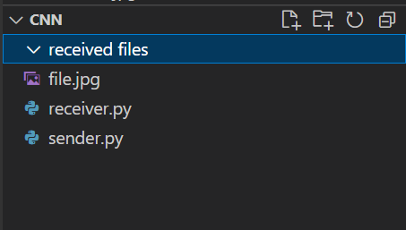

* After Transferring files:

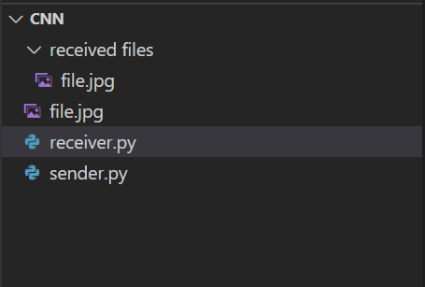

To transfer files:

